Ideation Phase

Brainstorm & Idea Prioritization Template

Date | 09 February 2026
Team ID | LTVIP2026TMIDS53841
Project Name | strategic product placement analysis: unveiling sales impact with tableau visualization.
Maximum Marks | 4 Marks

Step-1: Team Gathering, Collaboration and Select the Problem Statements
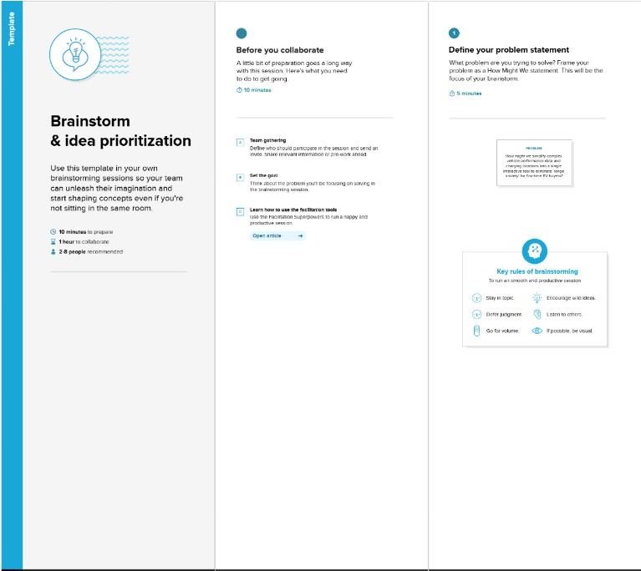
Step-2: Brainstorm, Idea Listing and Grouping
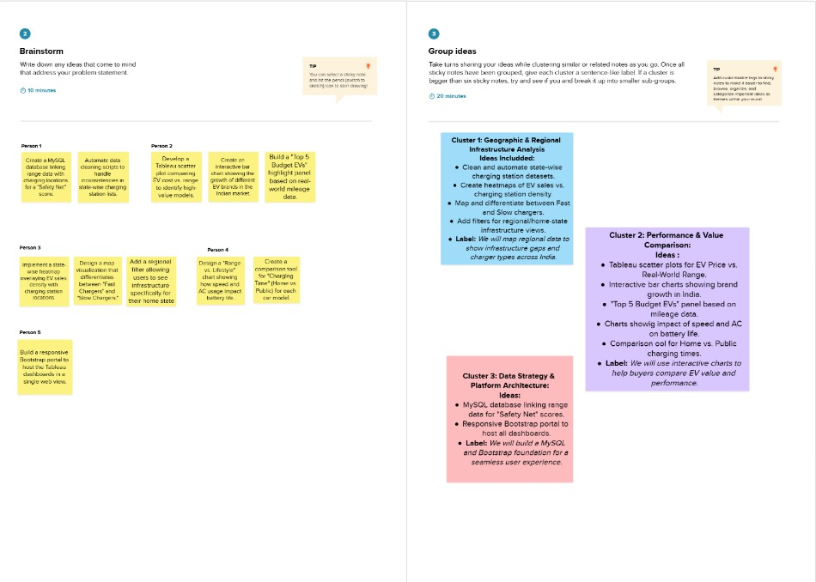

Step-3: Idea Prioritization
